John Vanhessche

Web 335

11/17/2022

Assignment 5.2

Adding a new user to the users collection

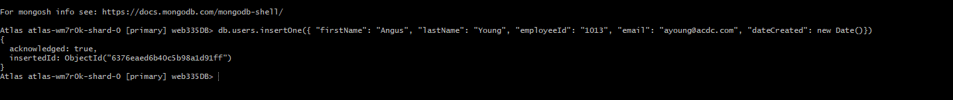

Updated Mozart Email Address



Query to show the updated email address

Query on only firstName, lastName and email, sorting by lastName ascending.

